# ABC Inventory Management

# Test Scenario: Beta Test Scenario 3

Table of Contents

ABC Inventory Management 1

Test Scenario: Beta Test Scenario 3 1

Scenario Description 3

Version Control 3

User Group 3

Test Log 3

Steps 3

Result Screenshots 4

# Scenario Description

This is the third Beta test scenario of ABC Inventory Management. The test was conducted by a third-party user to check if they could use the system as they wanted. No scripts were prepared so that the user had complete freedom to conduct any activity they wished for. All activities conducted by the user were logged when the user was conducting the tests. These logs were observed and documented in this document by the author. The basic information of the application and a user manual was provided to the user. The user was also given a warehouse staff password and a store staff password.

# Version Control

|  |  |  |  |
| --- | --- | --- | --- |
| Version Number | Date | Author | Description |
| 12.0 | 02/10/2018 | Shirish Maharjan | Initial Draft |
| 12.1 | 11/10/2018 | Shirish Maharjan | First Version (Iteration 6) |

# User Group

* Sophie Nguyen

# Test Log

## Steps

|  |  |  |  |
| --- | --- | --- | --- |
| Step | Test Action | Expected Results | Pass/Fail |
| 1. | Application is launched. | System displays the ‘Login’ Page with the Username and Password field empty. | Pass |
| 2. | User enters the provided warehouse staff username and password. | System waits for user to click on ‘Login’ button. | Pass |
| 3. | User clicks on the ‘Login’ button. | System grants access to the user and opens the Homepage with Warehouse Staff access. | Pass |
| 4. | User clicks on ‘Manage Product’ button. | System displays the ‘Manage Product’ page. | Pass |
| 5. | User clicks on the ‘Add New Product’ button. | System displays the Add New Product page. | Pass |
| 6. | User enters new product details. (User enters the product code as SN1) | System waits for user’s action. | Pass |
| 7. | User clicks on the ‘Add’ button. | System displays an error message prompting user to enter a valid product code. | Pass |
| 8. | User clicks on OK. | System displays the add product page and clears the product code field and with red border. | Pass |
| 9. | Users enters a S1 as a product code. | System waits for user’s action. | Pass |
| 10. | User clicks on the ‘Add’ button. | System displays an error message saying the product code already exists. | Pass |
| 11. | User clicks on OK. | System displays the add stored product page for the product code that was entered. | Pass |
| 12. | User selects a size and location and enters the quantity to be added. | System waits for user’s action. | Pass |
| 13. | User clicks on the ‘Add’ button. | System adds the entered quantity of the product size selected to the system and displays an appropriate message. | Pass |
| 14. | User clicks on Ok in the message displayed. | System displays the add stored product page again for the user to add more products. | Pass |
| 15. | User clicks on the ‘Homepage’ button. | System displays the homepage button. | Pass |

### Result Screenshots

**Step 1**

Application launched, and login page is displayed.

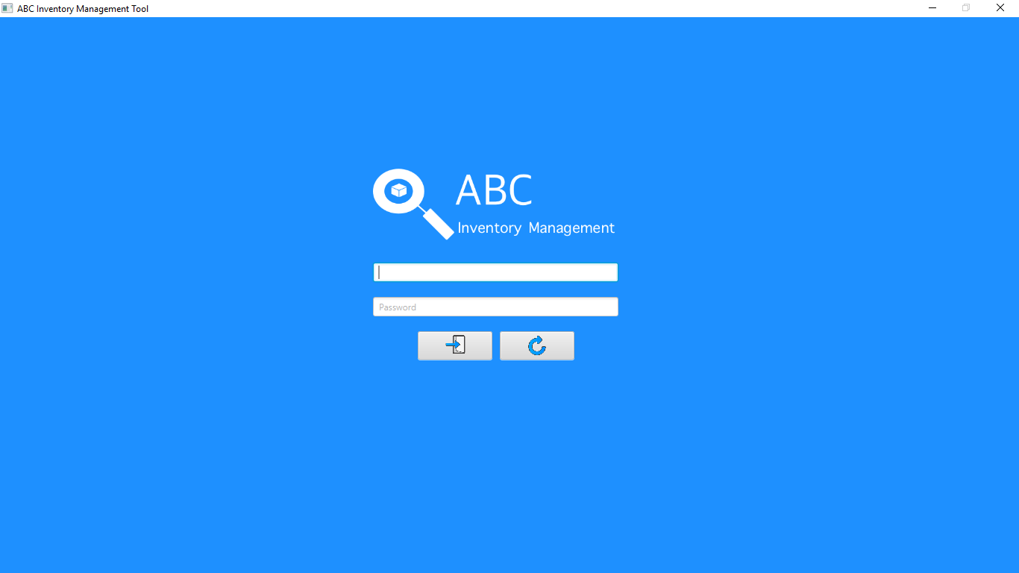

**Step 2**

Username and password are entered, and the system waits user to click on the ‘Login’ button.

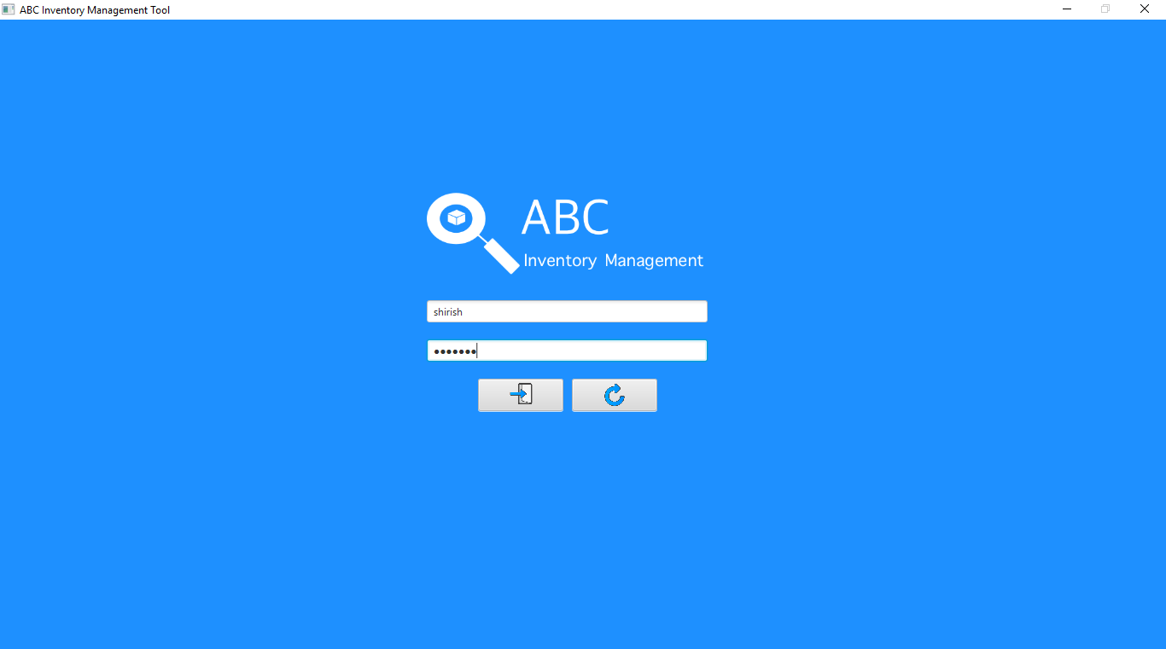

**Step 3**

After the user clicks on the login button, the homepage is displayed with warehouse staff access. The user then clicks on the ‘Manage Product’ button.

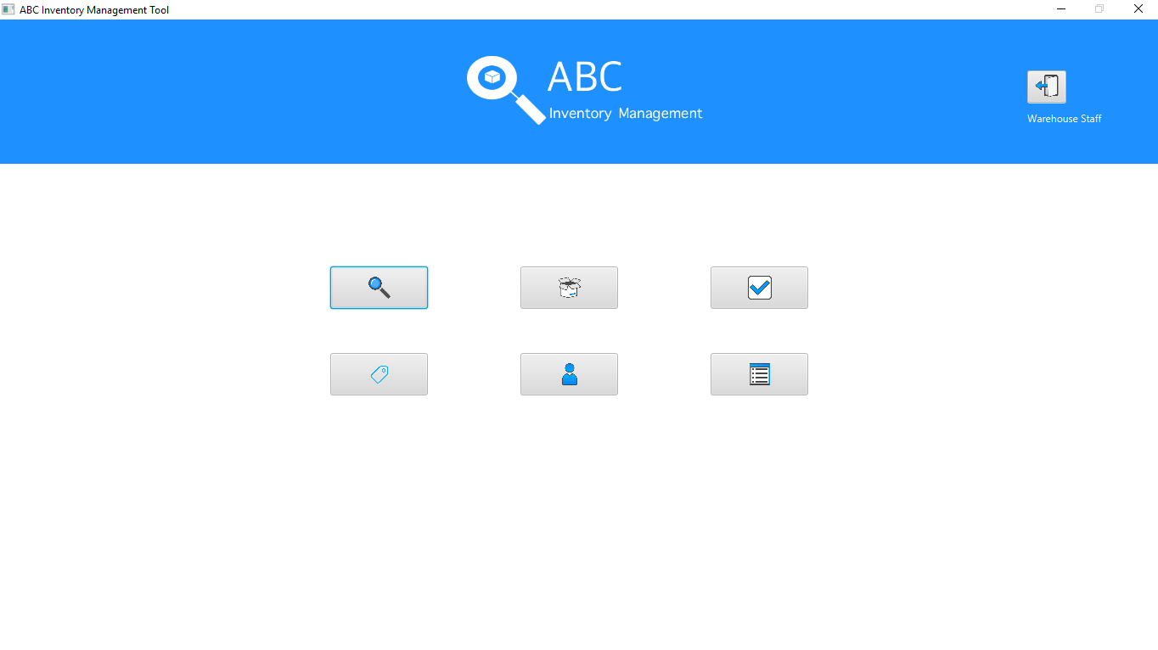

**Step 4**

After the user clicks on the ‘Manage Product’ button, the manage product page is displayed.

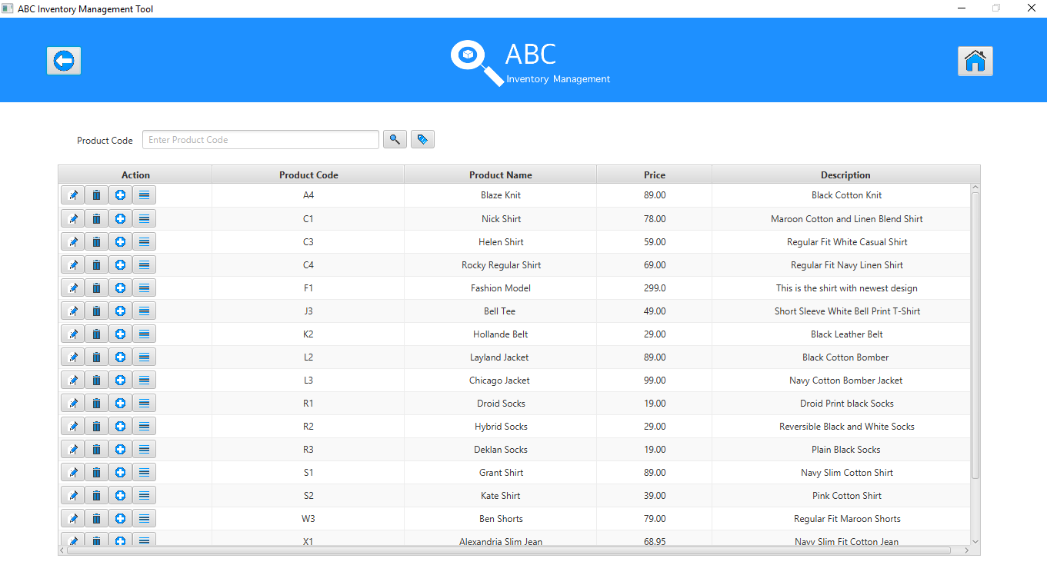

**Step 5**

After the user clicks on the ‘Add New Product’ button, the add new product page is displayed.

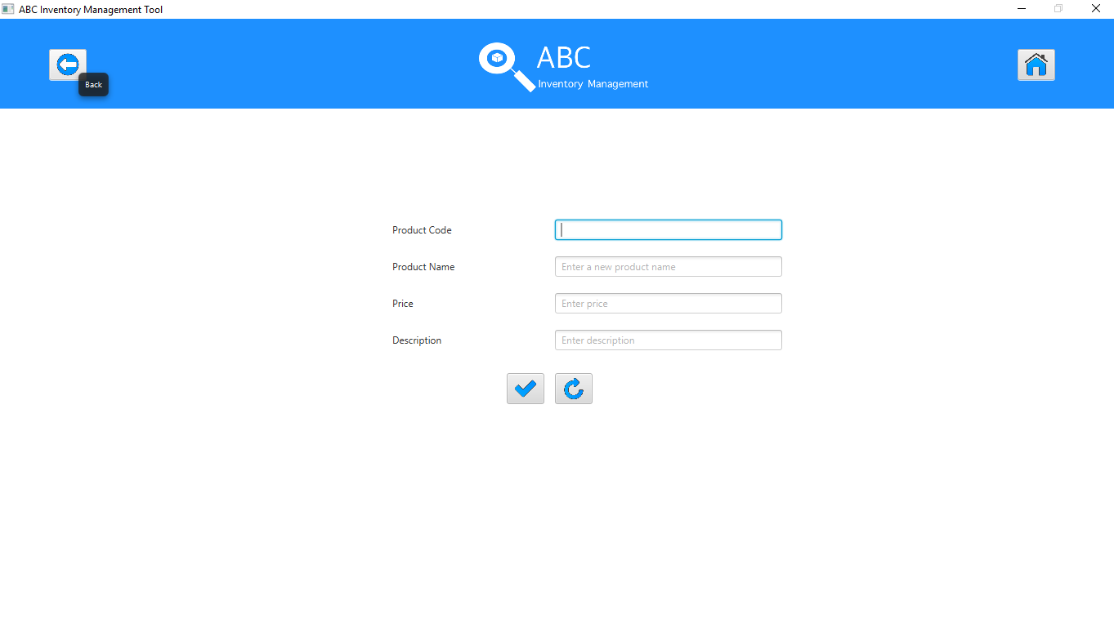

**Step 6**

User enters all the fields and enters the product code as ‘SN1’.

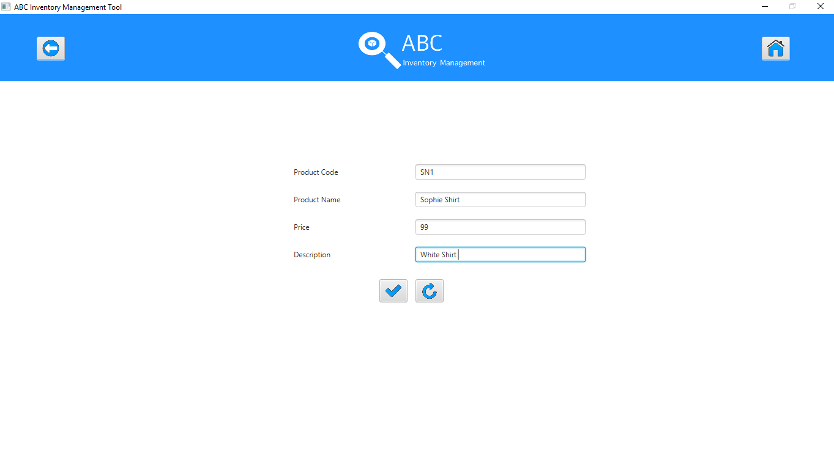

**Step 7**

When user clicks on the ‘Add’ button, an error message is displayed prompting the user to enter a product code of the correct format. The message also shows an example of the format the product code must follow.

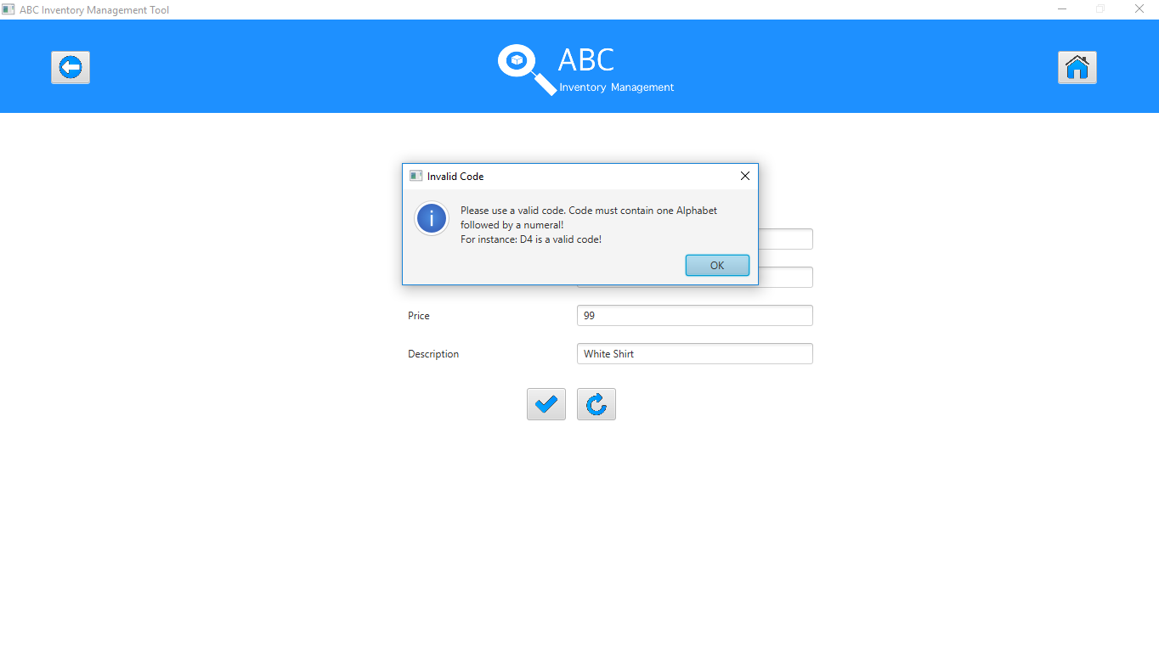

**Step 8**

After the user clicks on ‘Ok’, the system displays the add product page along with the details entered. However, the product code field is cleared, and the border color is changed to red.

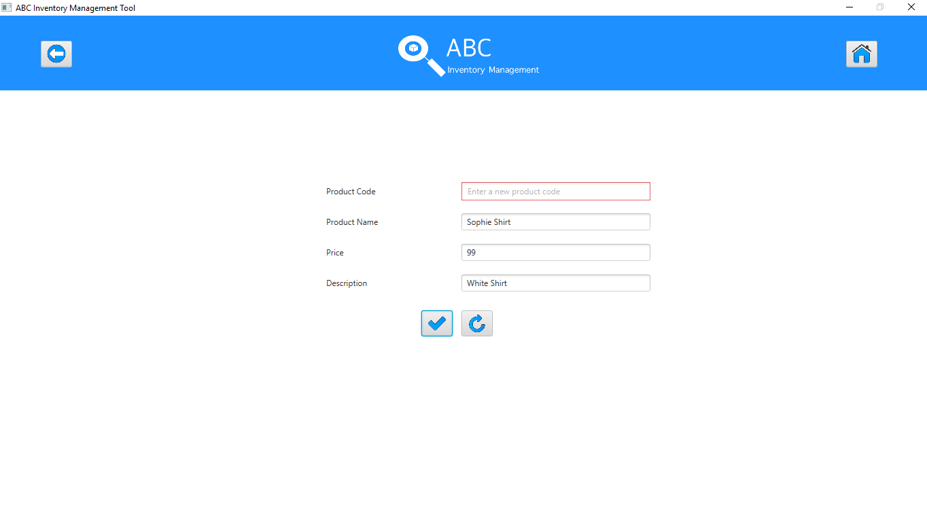

**Step 9**

The user enters the product code as S1.

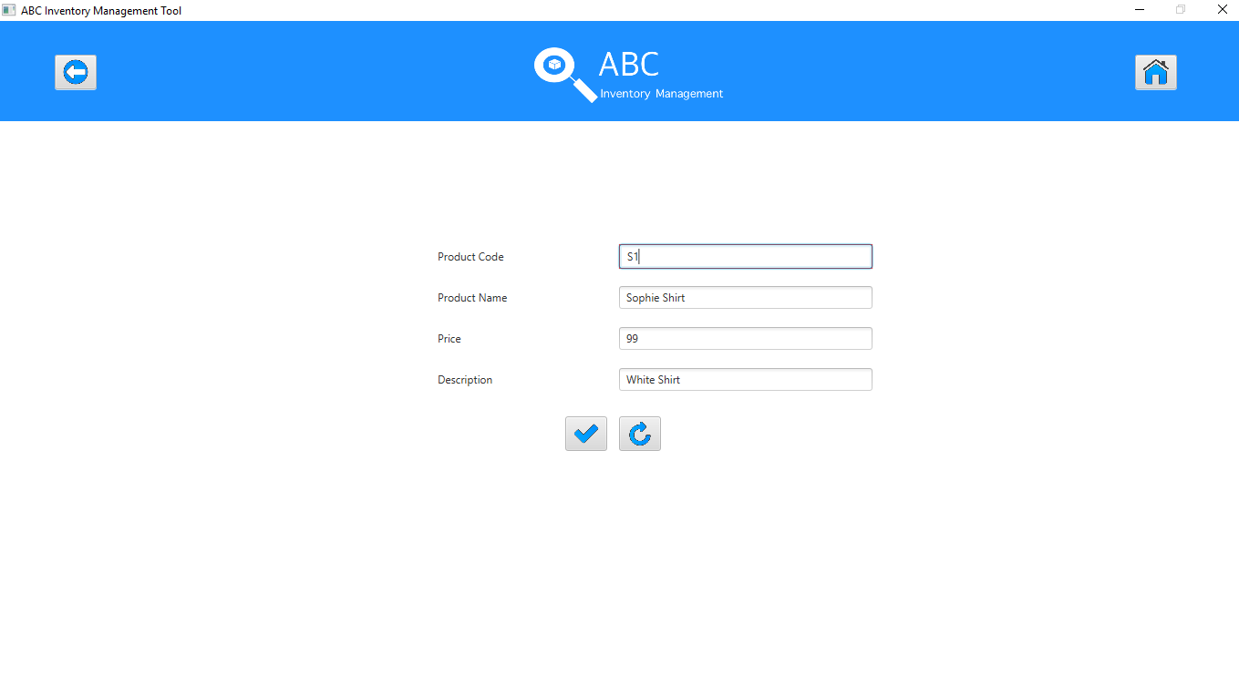

**Step 10**

After the user clicks on the ‘Add’ button, the system displays an error message saying the product already exists.

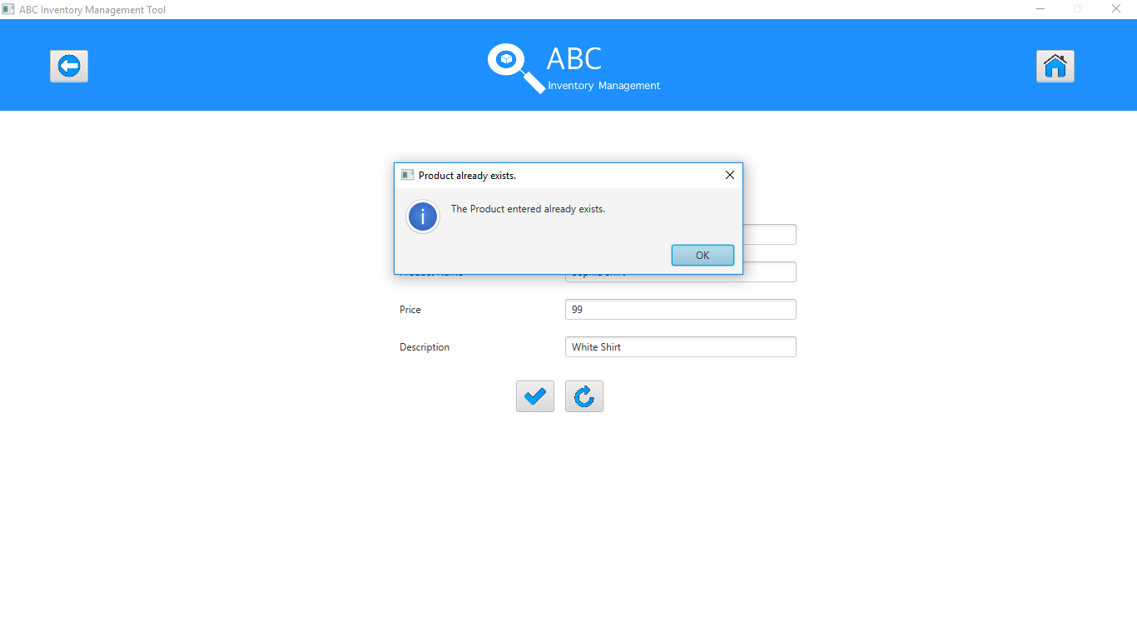

**Step 11**

After the user clicks on OK, the system displays the page through which desired quantity of a product size can be added to a location for the product that was entered earlier.

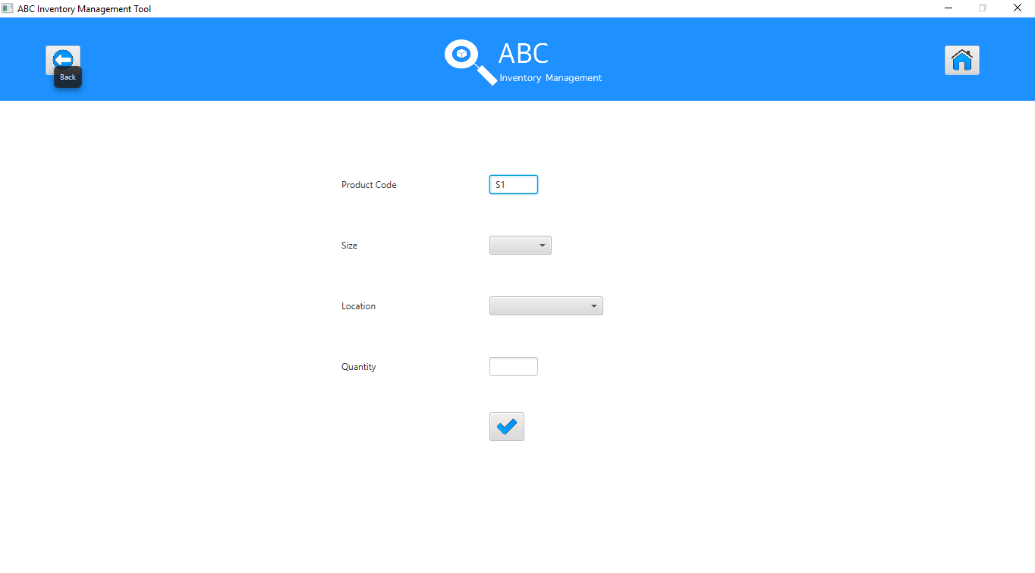

**Step 12**

User selects a size and location and enters a quantity.

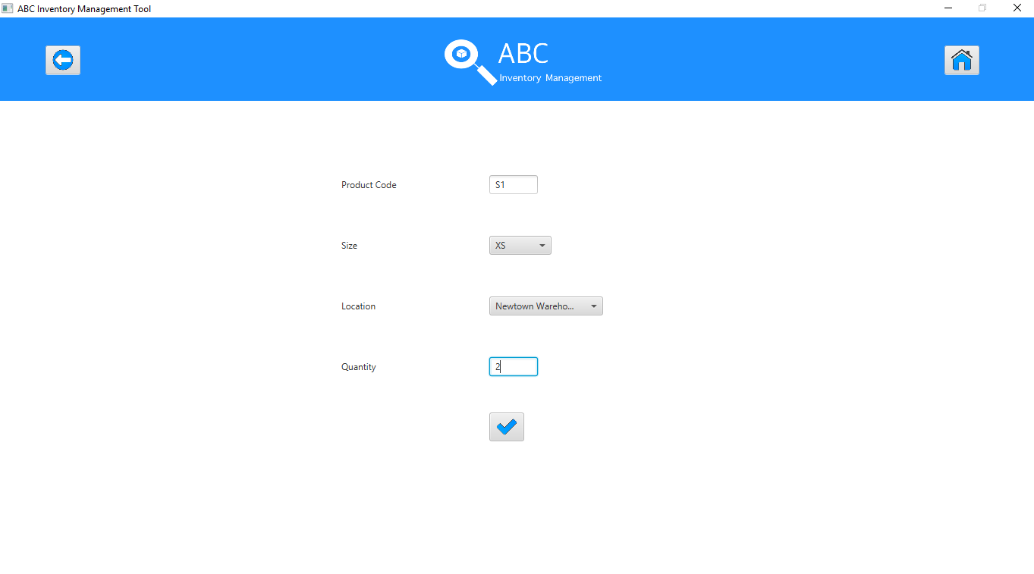

**Step 13**

After the user clicks on the ‘Add’ button, the system displays a message saying the product size was added to the selected location.

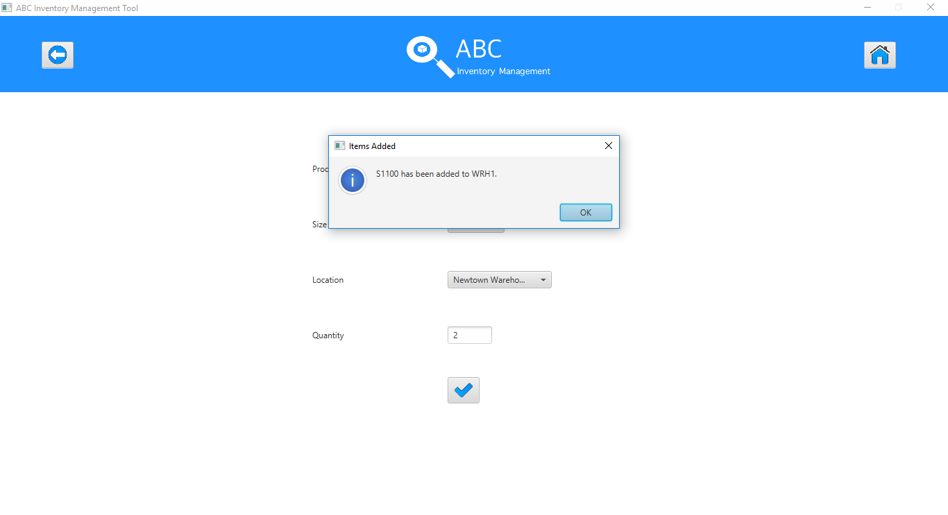

**Step 14**

After the user clicks on Ok, the system displays the Add Stored product page again.

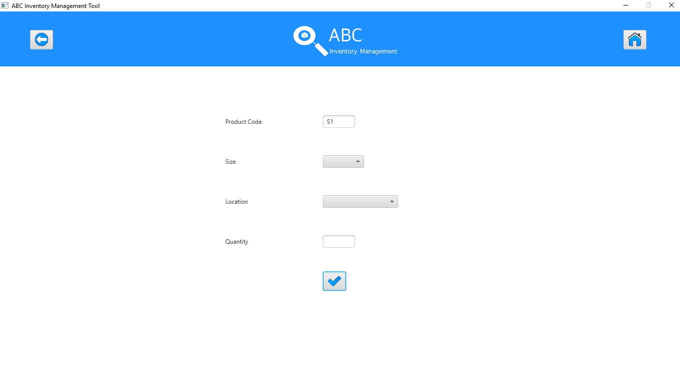

**Step 15**

After the user clicks on the ‘Homepage’ button, the system displays the homepage.

